Task 3a: Gathering Feedback to Inform Future Development
Student Name: Saim Fareed
Registration Number: LL-000022787
Introduction – Purpose of Gathering Feedback
The purpose of this task is to gather feedback on my Greenfield Local Hub prototype from two different types of audiences technical and non-technical. Gathering feedback is an important stage in the software development process because it will help me understand how real users interact with the system and what problems they might face. It is called User Acceptance Testing or UAT and it is a way of making sure the prototype actually meets the needs of the people who will use it not just the technical requirements written in the brief. By collecting and gathering feedback from both technical and non-technical people I can get a complete analysis of what works well and what needs improving.
This feedback will help me identify at least three to five areas for improvement before any final release. It will also help my evaluation in Task 3b where I will analyse the feedback in more detail and suggest future developments.
Feedback Planning:
Purpose and Objectives:
The purpose of this feedback cycle is to carry out User Acceptance Testing within an iterative approach. By gathering real opinions and observations from different types of users I’ll be able to findout whether the prototype that I developed meets my functional requirements and if it is easy, pleasant and comfortable to use.
I’ve set the following objectives for this feedback session:
Objective Type | Objective Statement
Usability | To ensure that 100% of testers can complete a full customer journey from browsing products, adding to basket, checking out without external guidance
Design Clarity | To achieve an average score of 4 out of 5 or higher on questions about navigation and layout etc
Technical Reliability | To identify and document at least three technical issues or areas for improvement
User Experience | To collect at least two qualitative suggestions for feature enhancements that would benefit the target audience

Audience Profiles:
I Identified two different audiences for my feedback sessions.
Technical Audience:
The technical audience are people who are experience with programming, databases or IT systems. This includes computing students and anyone who understands how websites really work behind the scenes. They will focus on the things like system performance, database structure, code organisation, security measures and error handling. Their feedback will help me improve the reliability and maintainability of the prototype. For this task I selected three technical testers Callum, Taylor and Roddick. All of them are studying computing or have done complex computer projects in the past.
Non-Technical Audience:
The non-technical audience consists of people who don’t have a background in computing or programming. They are more like real customers or end users. They will focus onthings like how easy the website is to use whether, the design of the site looks professional, if the text is easy to read and whether the layout makes sense. Their feedback will helpme improve the user experience and make sure the website is accessible to everyone.
For this task, I selected three non-technical testers Taya, Pippa and Raya. They do not take computing courses and have limited technical knowledge which makes them perfect for presenting real customers.
Methods of gathering feedback:
- Sending out any survey/form
- Live Chat
- Doing user testing and seeing what features rememebers first, test opinions on logos and marketing materials
- Test user clciks, navigation, page visited
- Email Surveys
- Social Media
- One to one call, let them use the prototype and gather feedback ny asking questions
Methods of presenting the prototype:
- Creating video to showcase what the website can do, error checking and demonstrating features
- By sending coe files
- Attaching screenshots of different pages, features and databases etc
Tools for Gathering Feedback:
- Microsoft forms
- Type Forms
- Google Forms
- Zoho Survey
- Survy Planet etc
Choosen Feedback methods:
To gather structured and useful feedbackl I used a mix methods approach meaning I collecetd bothh quantitative data which is ratings and scores and qualitative data which are written comments and suggestions.
Questionnaires:
I created two separate questionnaires. One was for technical testers and one was for non-technical testers. Each questionnaire had 15 questions. Questions asked for rating from 1 to 5 stars and written comments. This approach gave me numbers and detailed data for analysis which I could compare and detailed opinions I could learn from.
Observation Walkthrough:
Before giving out the questionnaires I showed each tester screenshots of every page and detail to walkthrough of the prototype. This demonstrated all the key features including browsing products, adding to basket, checking out, logging in and registering, the producer dashboard, the loyalty points system and the map on the About page. This made sure every tester had seen the same features before giving feedback.
Layout Demonstration:
This demonstratiom shows the homepage layout.
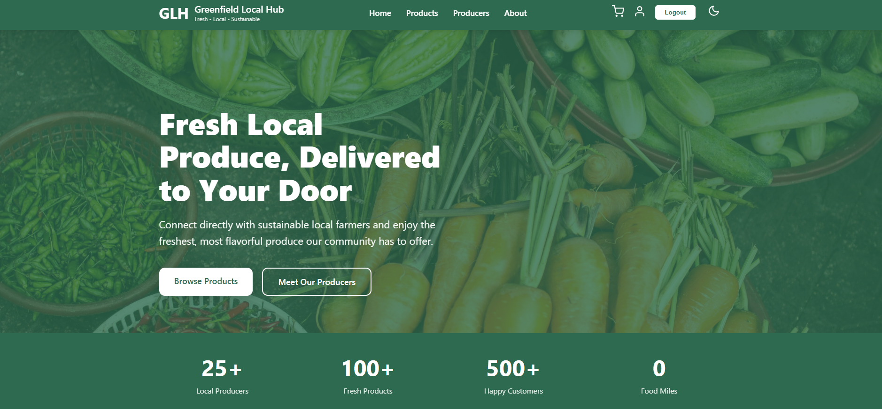
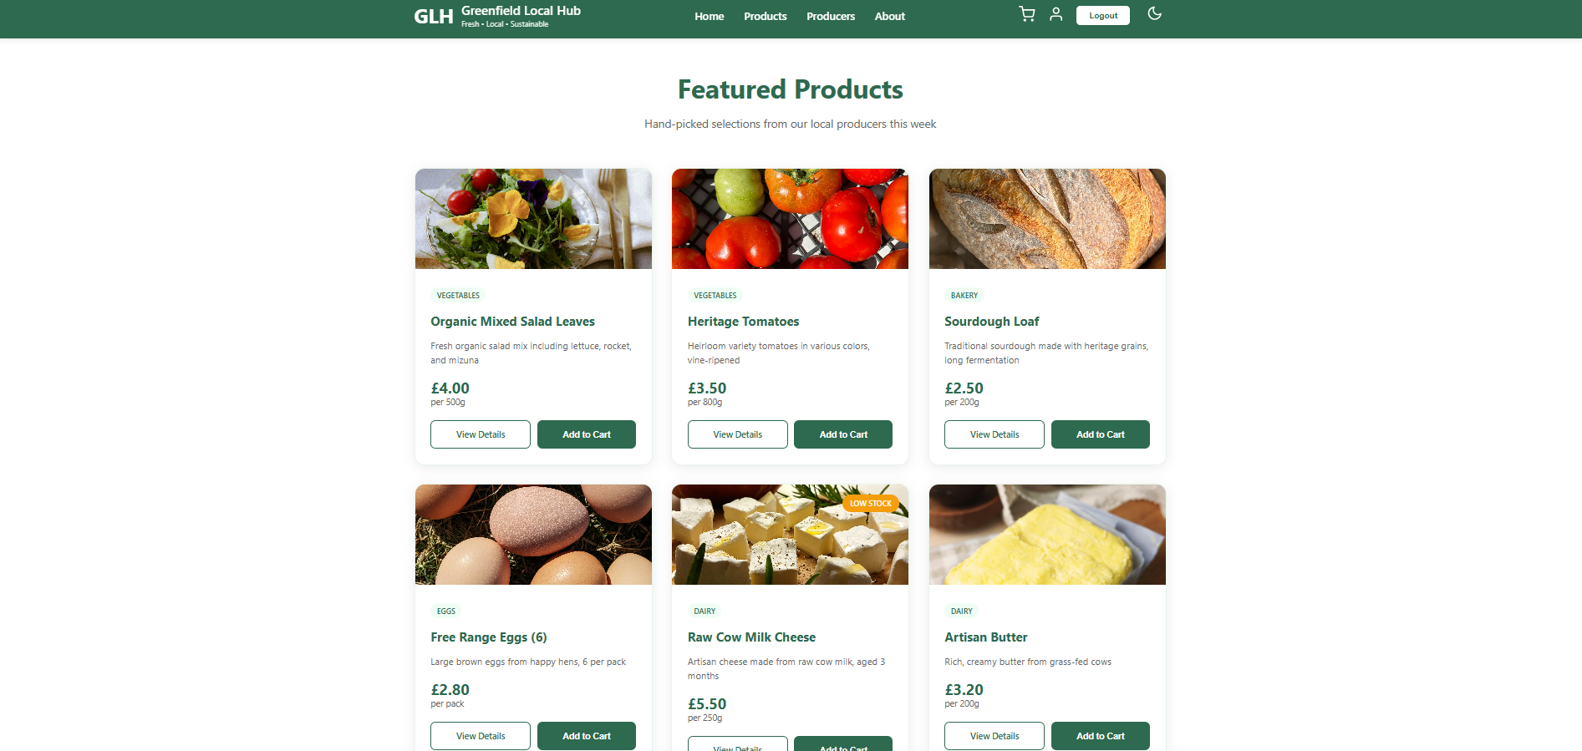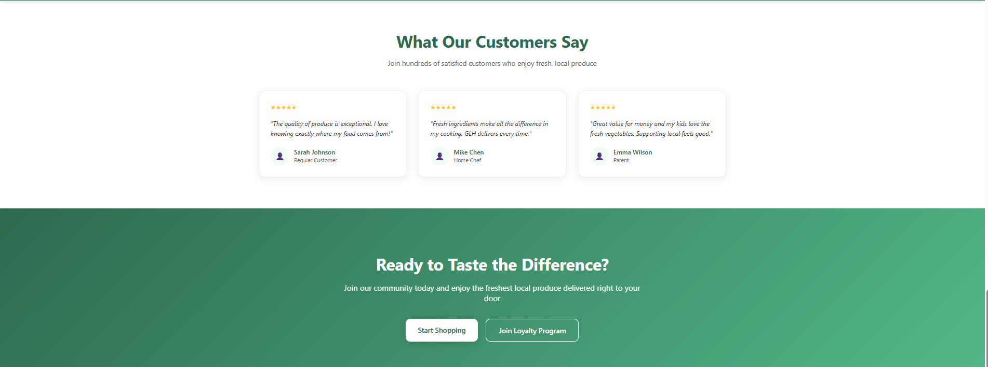
Products Page:
Demonstration of the Products page
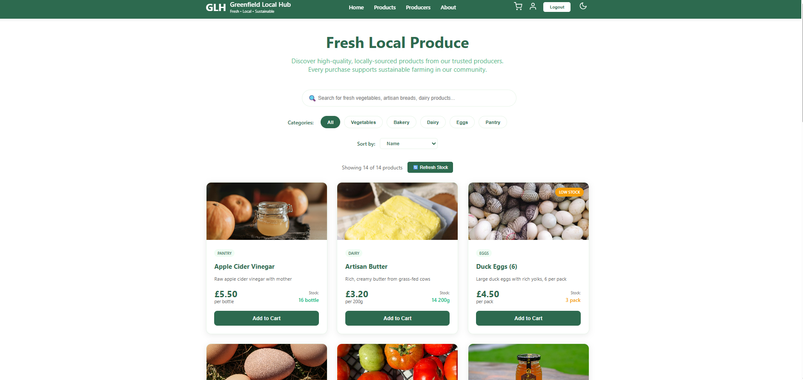
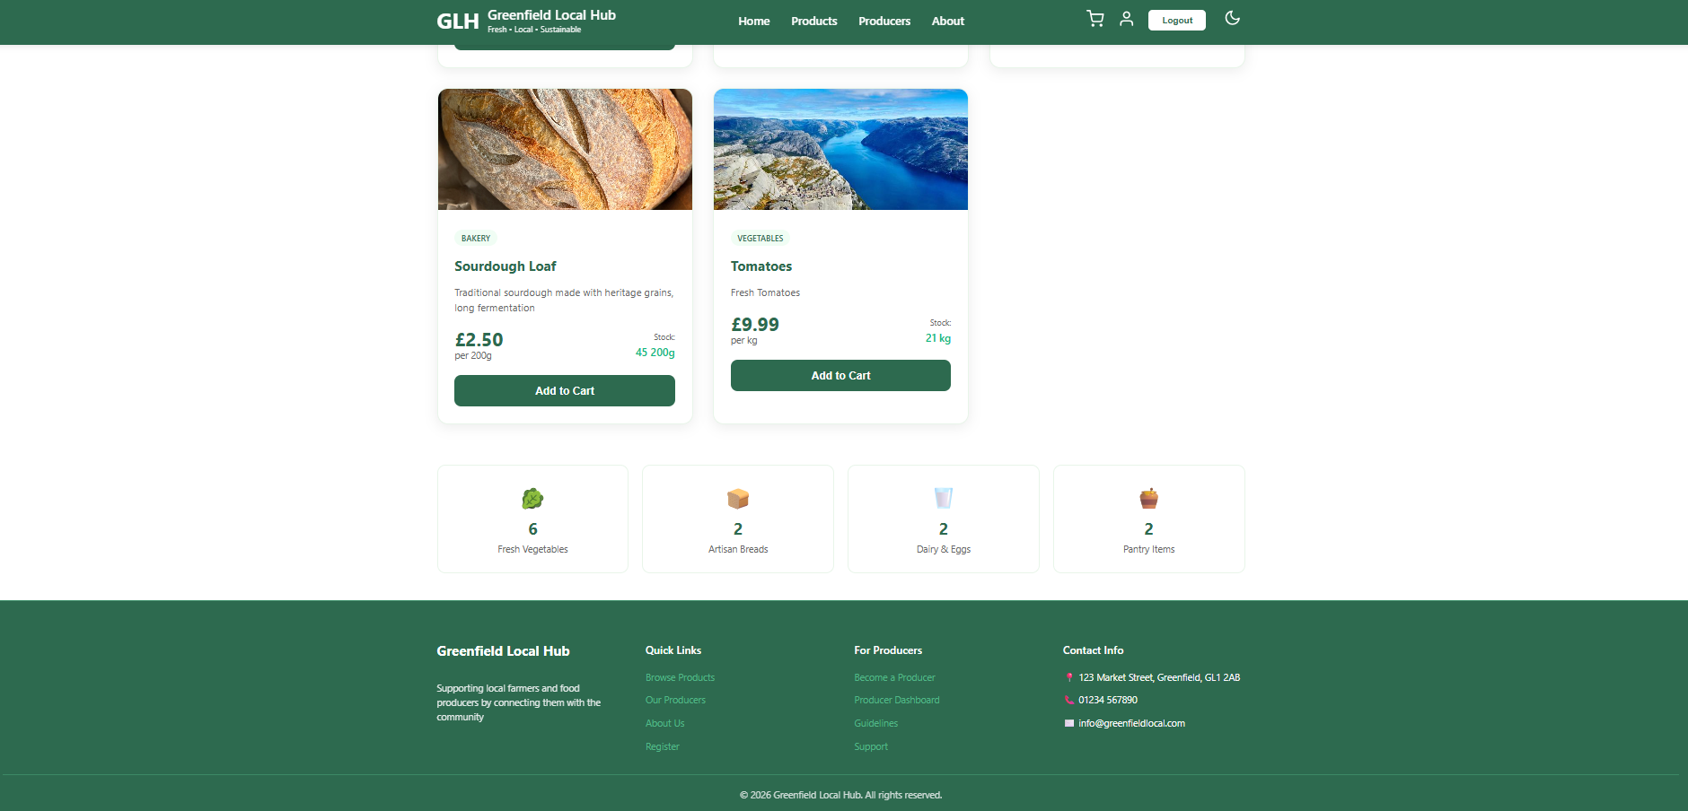
Producers Page:
Demostruction of the producers page showing the producers.
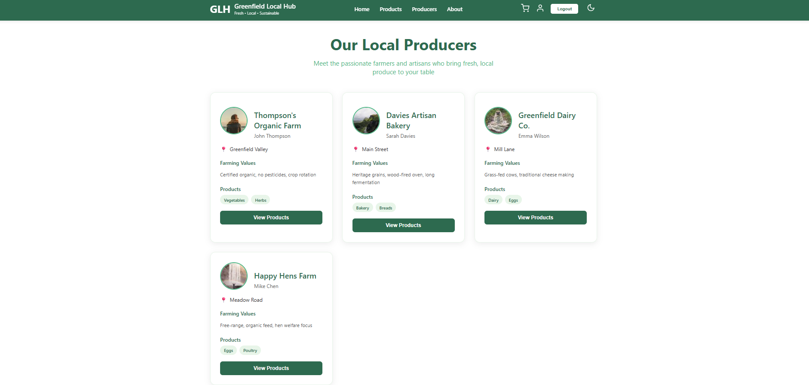

About Page:
Demonstration of the about page showing map and popups for the producers.
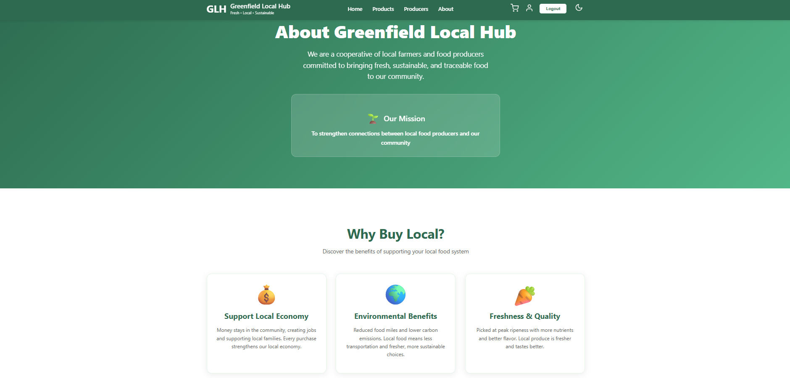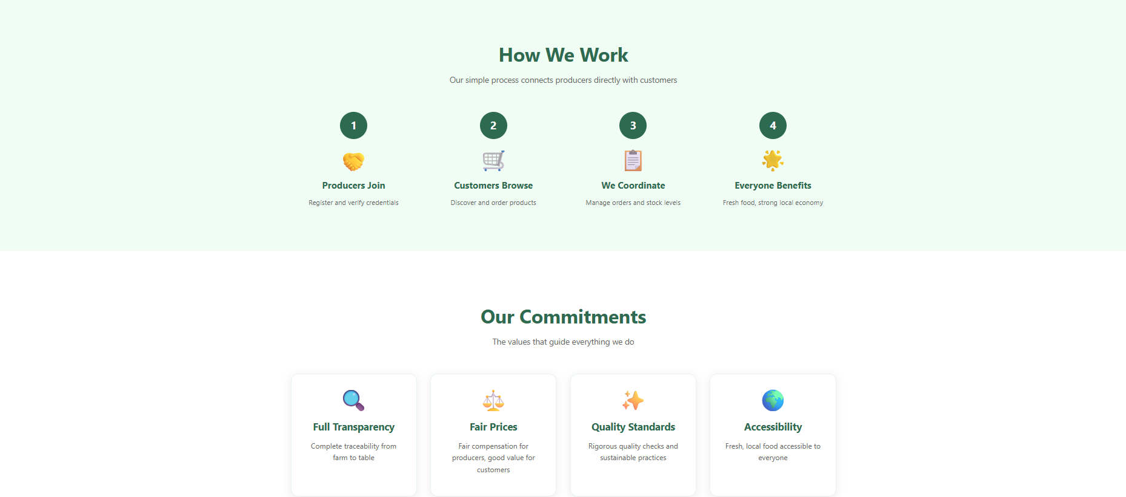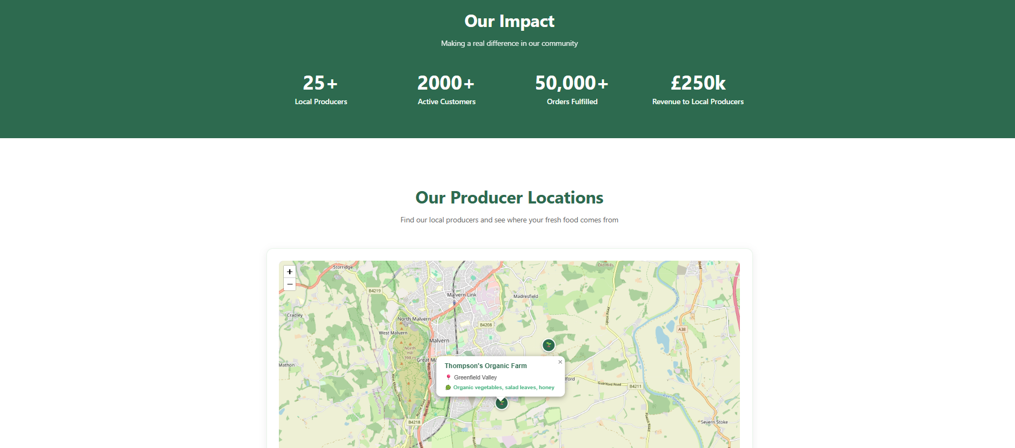

Basket Page:
Demonstration of the Baket page showing the adding and removing of items and changing the quantity
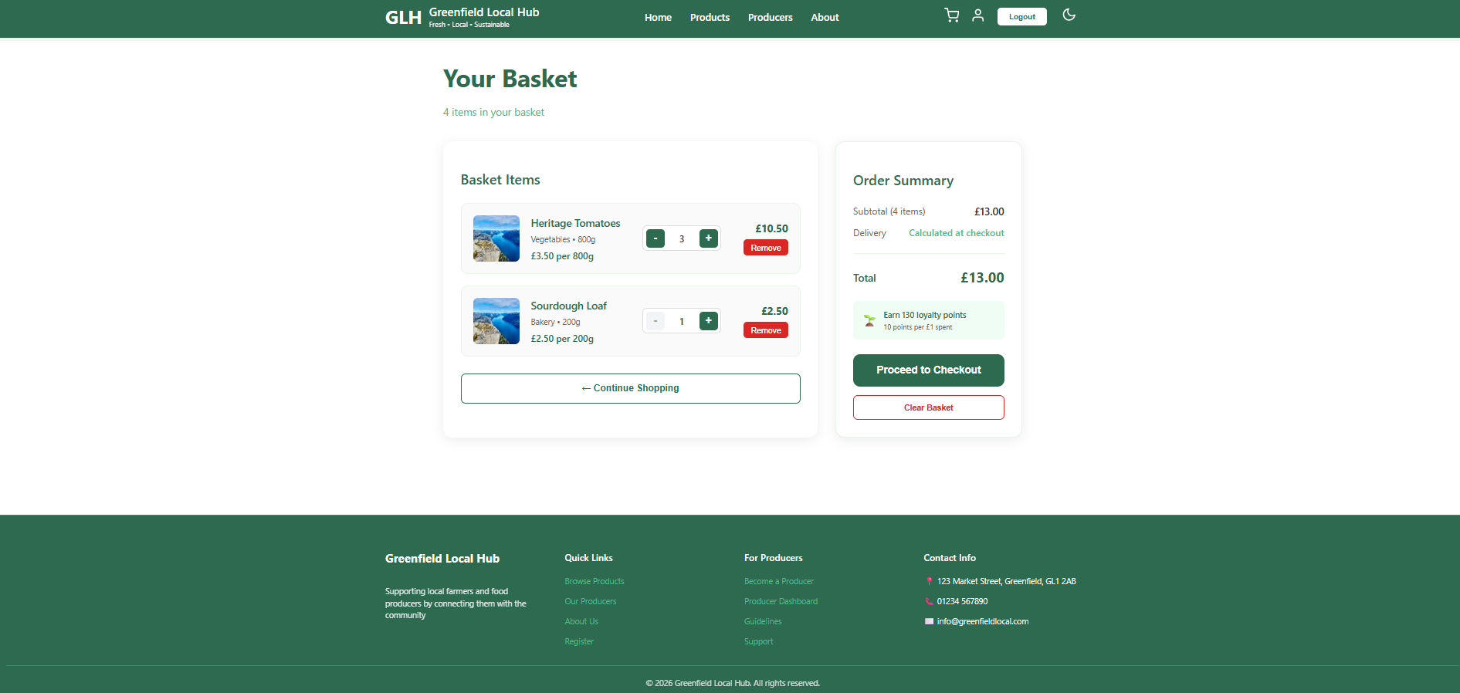
Checkout Page:
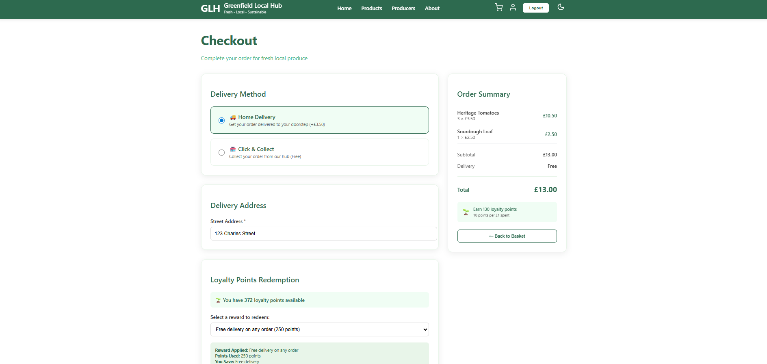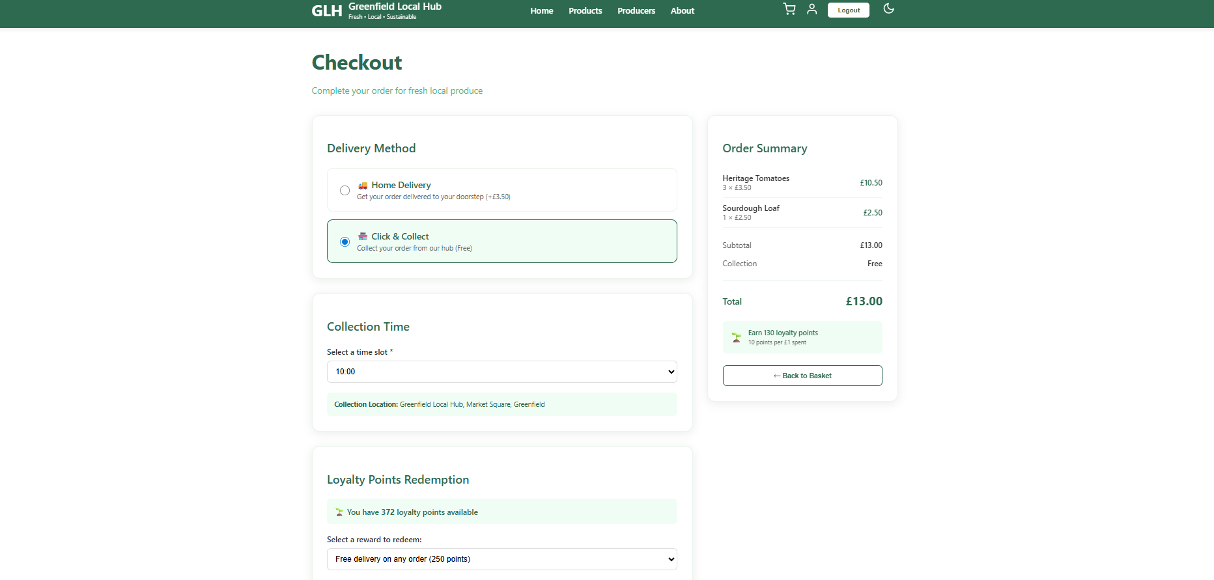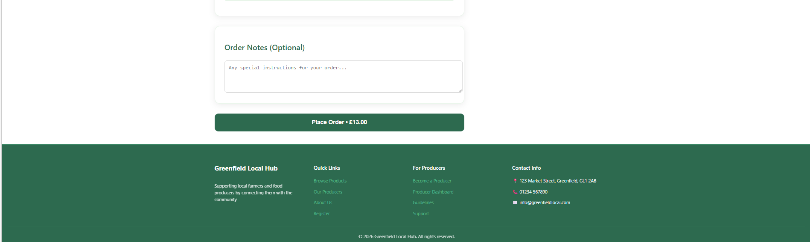

Account Page:
Demonstration of Account page after placing the order. Account page showing the order history am the loytalty points etc.
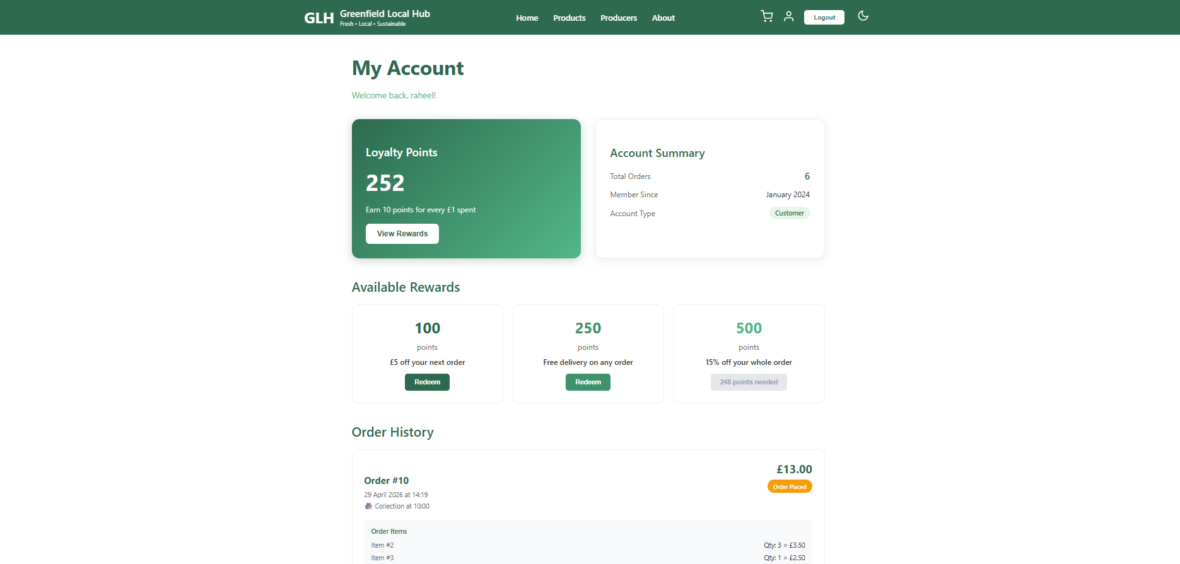
Login & Registration:
Demonstration of Login and Registration page showing the users logging in and registration of the users.
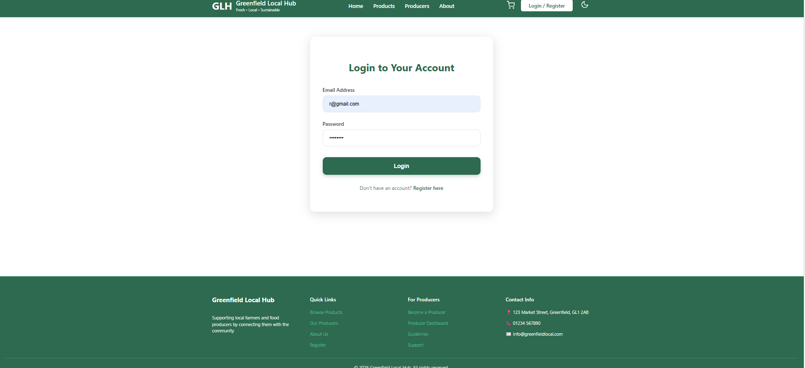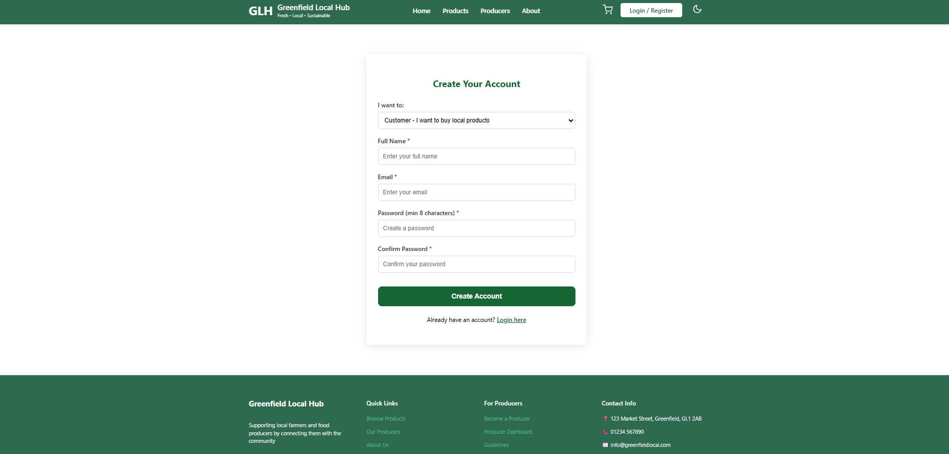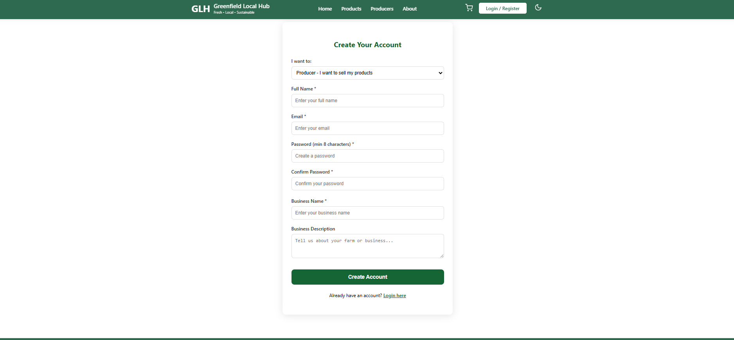

Producer Dashboard:
Demonstration of the Producers dashboard showing the producers items other details.
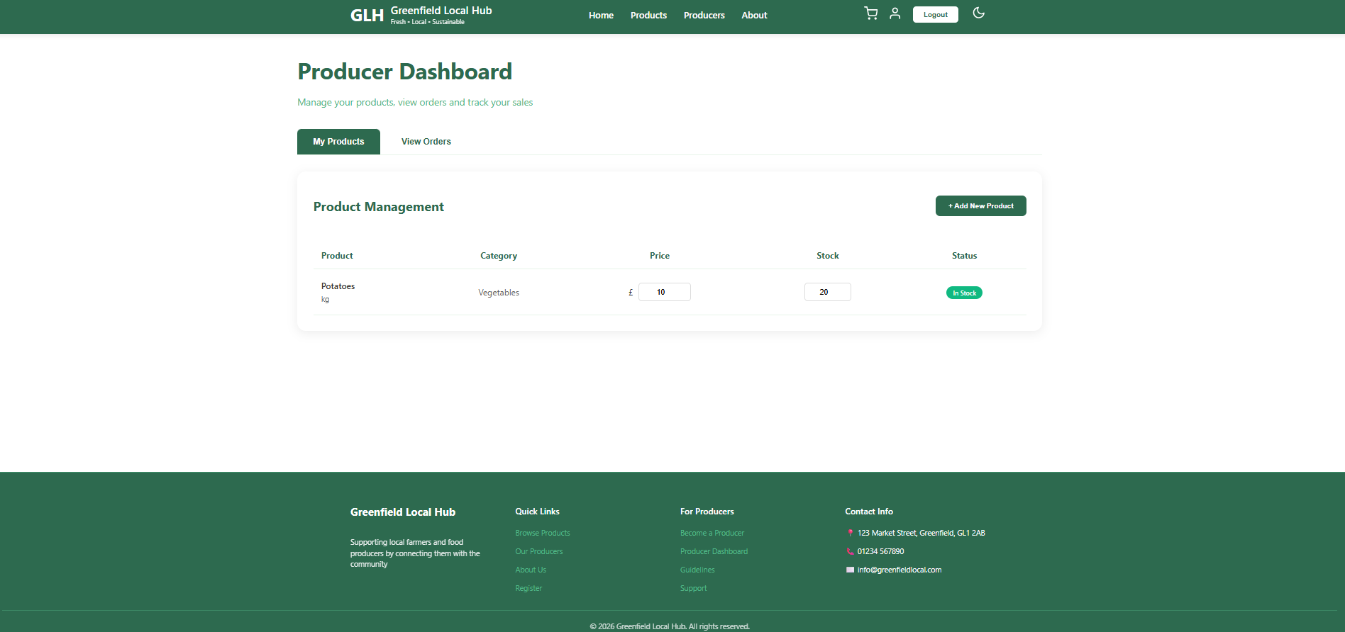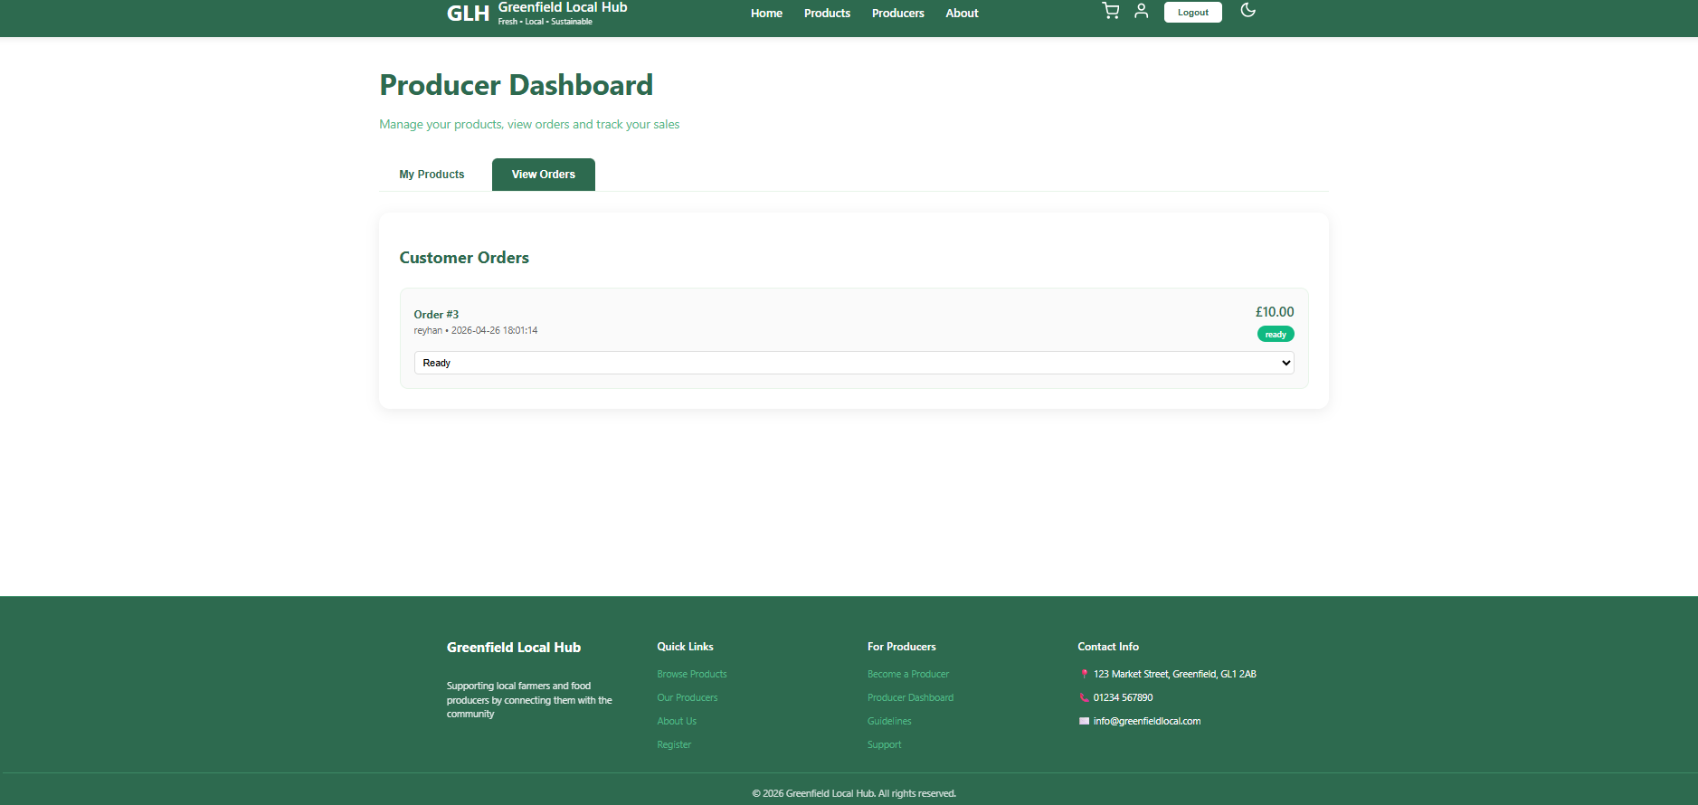
Dark Mode:
Demonstartion of dark mode on the different pages.
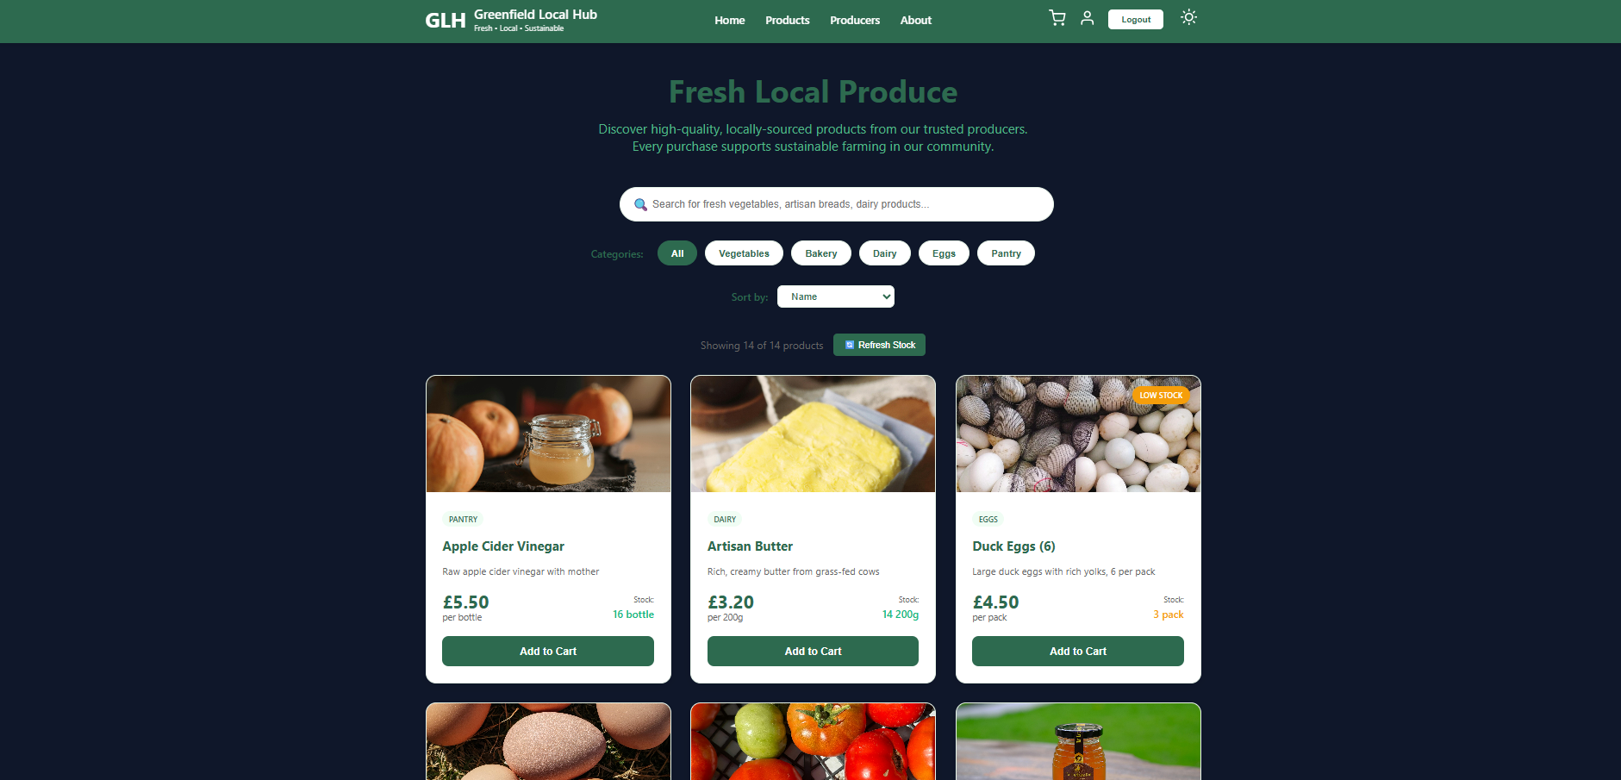
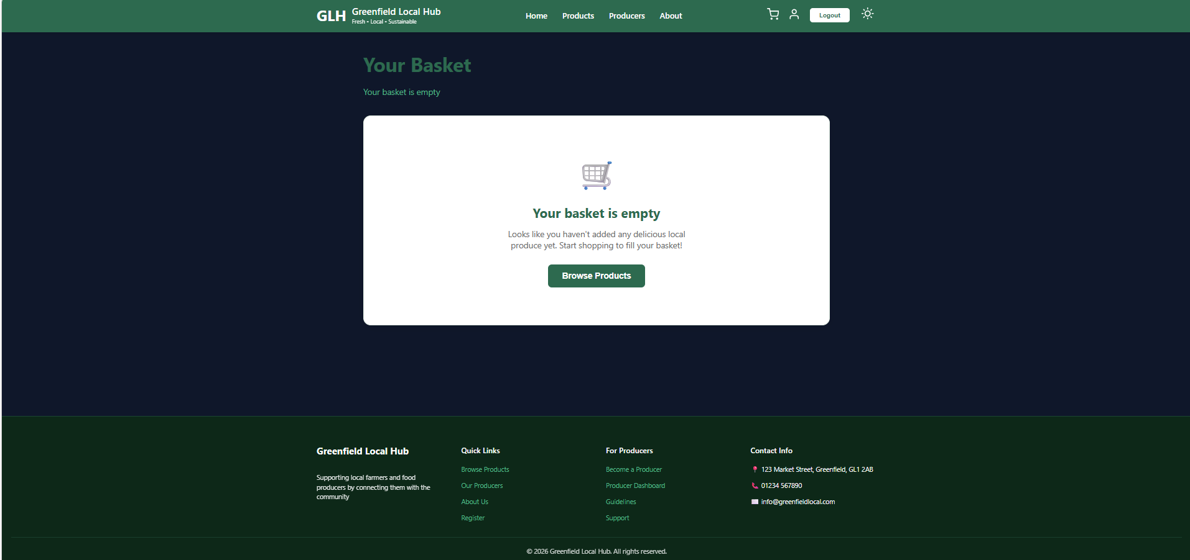
Code Snippets:
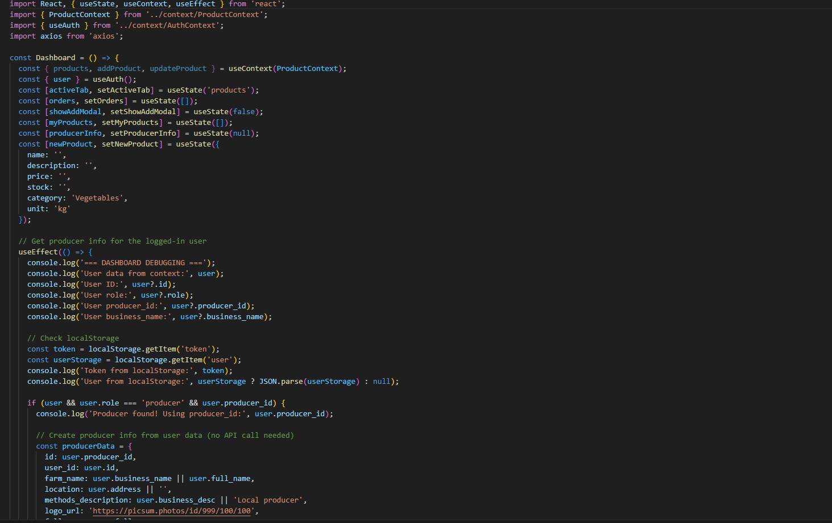
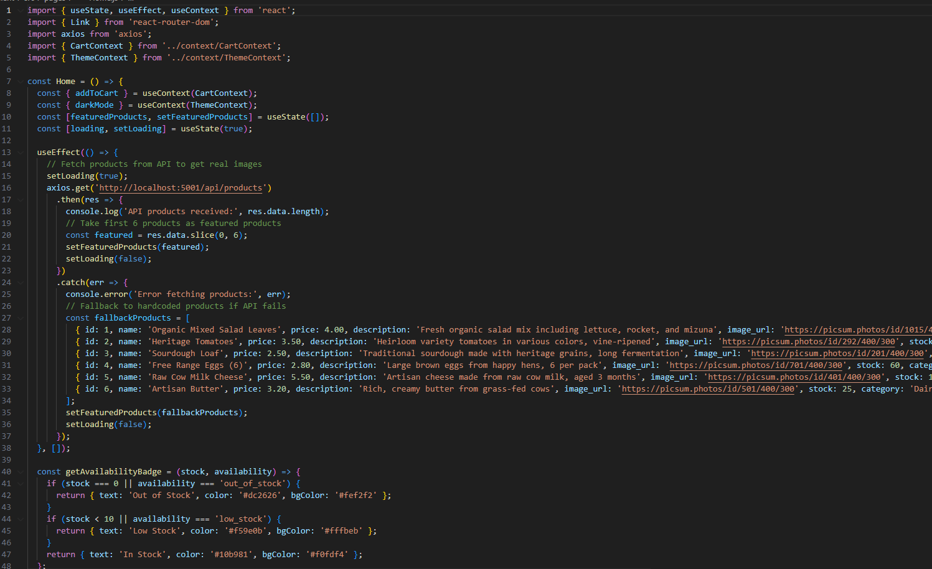
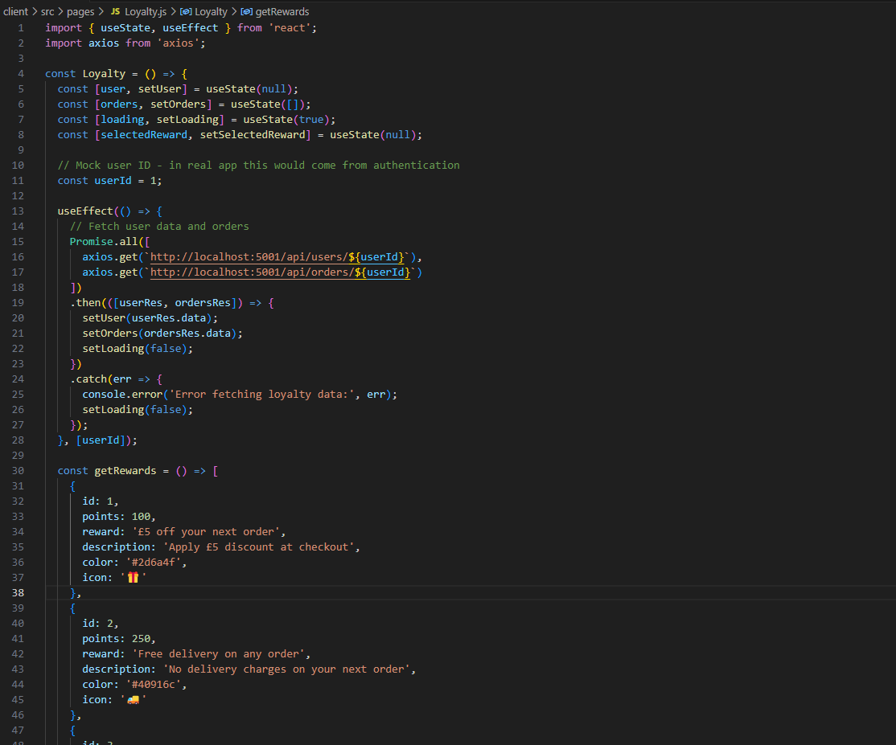
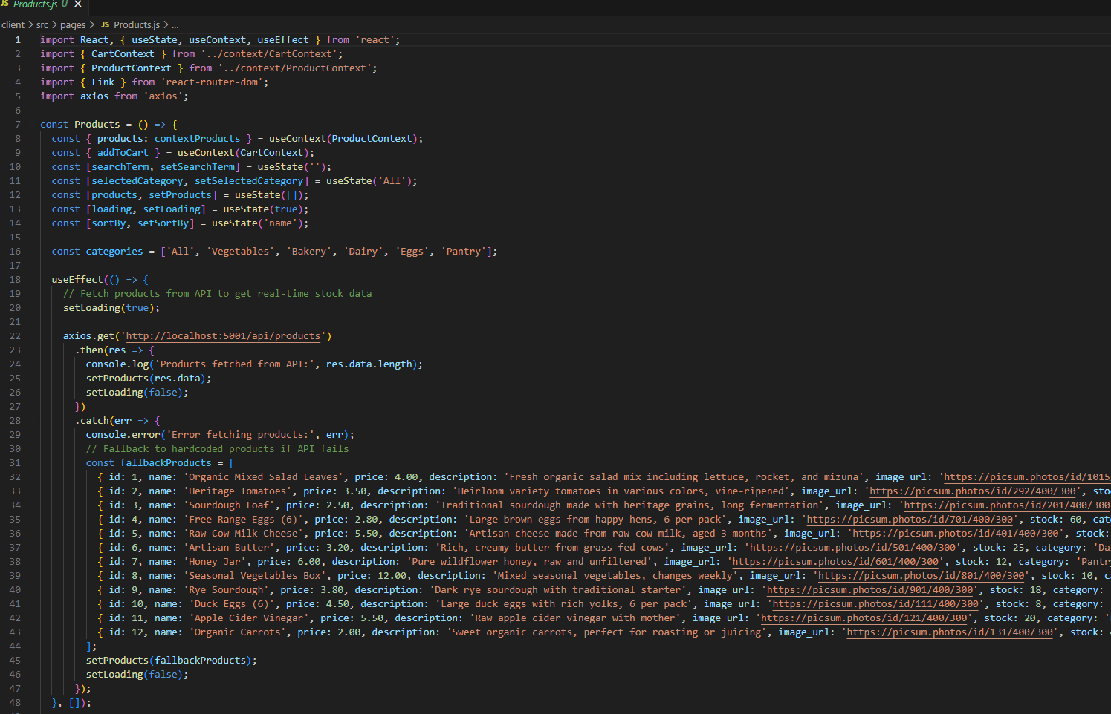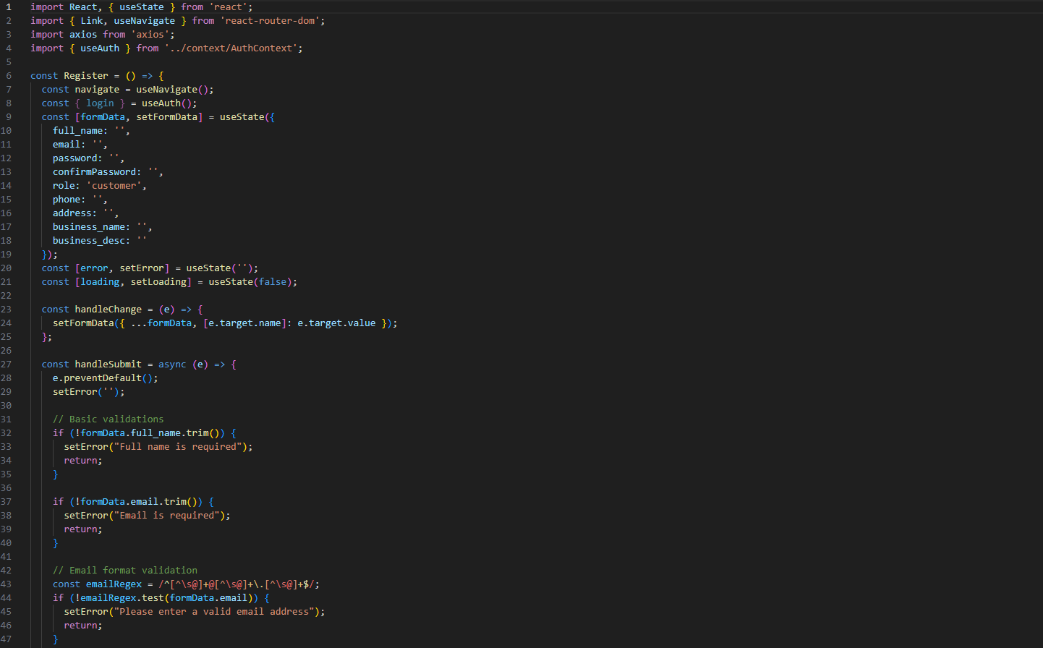

SQL Databas:
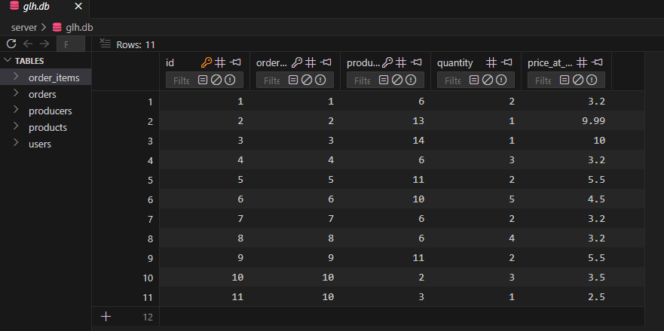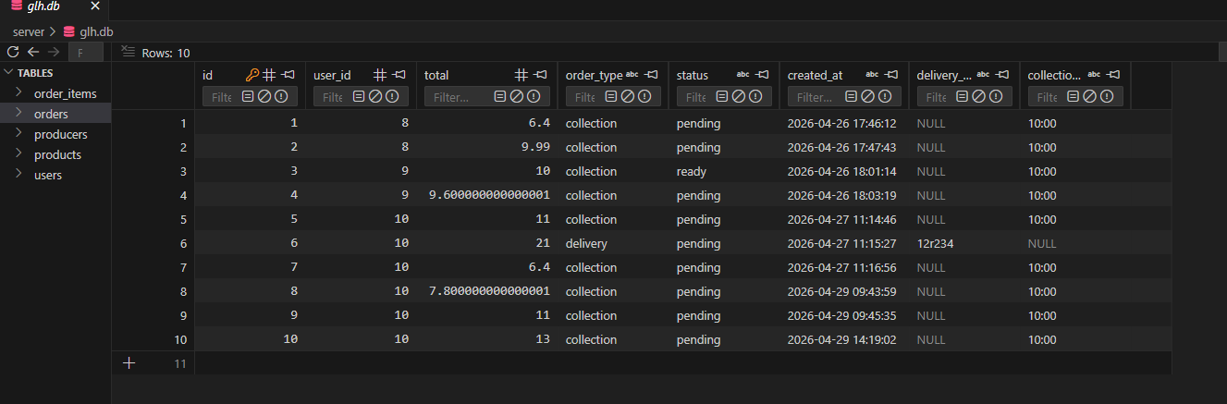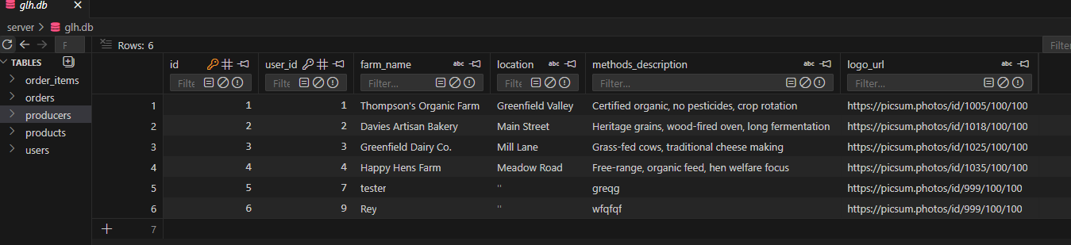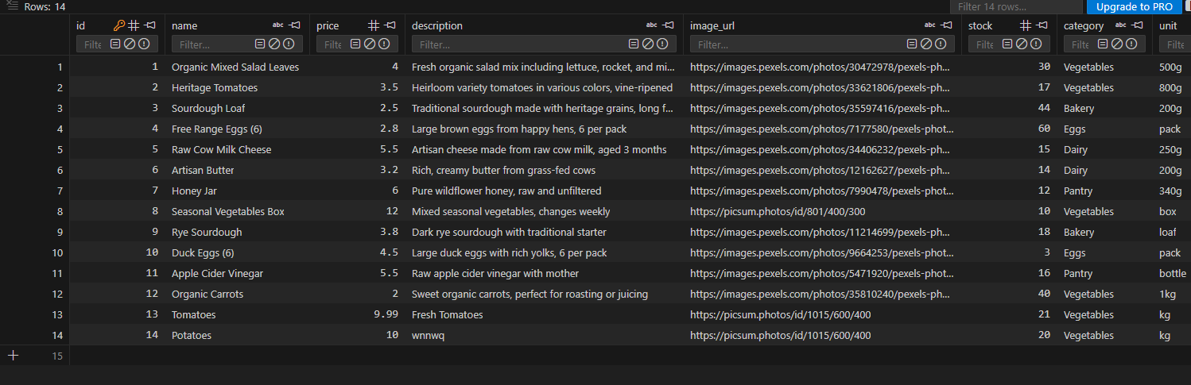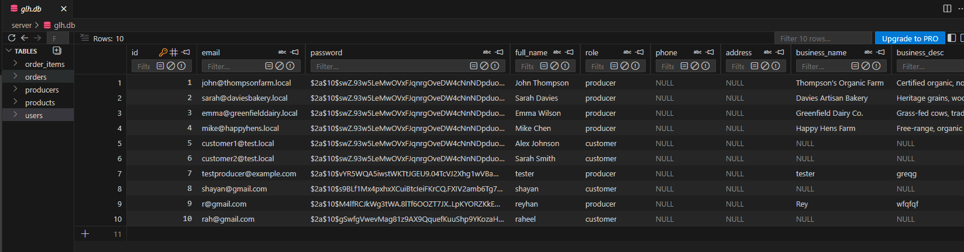
Why I chose these methods:
I chose this questionnaire because it is asy to distribute and record responses from the audience. I chose separate questionnaires for technical and non-technical audiences because they focus on different things. A technical tester cares about code quality and database structure while a non-technical tester more cares acout whether the buttons are eay to find and if the text is readable or not. By having separate questionnaires I ensured that each audience answered quetions that were relevant to them.
Materials for Demonstration:
Demonstrations for Technical Audience:
For the technical audience I recorded detailed screenshots of every page of the website to walkthrough that showed not just what the website does or ow it look but also how it works behind the scenes. The demonstration included:
- A tour of all the main pages Home, Products, Producers, About, Account, Basket, Checkout and Producers Dashboard
- A look at the SQLite database showing the tables users, products, orders, order_items, producers
- How products are fetched from the database and displayed on the Products page
- How orders are saved to the database when a customer checks out
- How loyalty points are calculated and stored in the users table
- How the producer dashboard filters products by producer_id
- The map API on the About page showing how external services have been integrated
Technical materials also included screenshots of key code snippets.
Demonstration for Non-Technical Audience:
For the non-technical audience I did the same to walkthrough that focused on what the website does rather than how it works. I didn’t use technical words like API, endpoint and database query. I explained things in simply like to any other normal user instead.
The demonstration showed:
- How to browse products and see prices and stock levels
- How to search for a specific product or filter by category
- How to add items to the basket and change quantities
- How to choose delivery or collection at checkout
- How to create an account and log in
- How to see order history and loyalty points on the Account page
- How the dark mode toggle works
- How the map shows where the producers are located
I focused on showing the benefits of each feature rather than explaining the technology and the code behind it.
Feedback Questionnaires:
Technical Auience Questionnaire:
Question No. | Question | Type of Response
1 | How easy was it to understand the structure of the database from what you saw? (1 = very difficult, 5 = very easy) | Rating 1-5/Comment
2 | Do the table names and column names make sense? Are they named consistently? | Rating 1-5/Comment
3 | How efficient does the product filtering and search functionality seem? | Rating 1-5/Comment
4 | Did you notice any potential security issues (e.g. with login, registration, or order placement)? | Rating 1-5/Comment
5 | How well does the producer dashboard filter products so producers only see their own items? | Rating 1-5/Comment
6 | Is there any part of the code or system architecture that you think could cause performance problems? | Rating 1-5/Comment
7 | How clear were the error messages when something went wrong (e.g. wrong password, insufficient stock)? | Rating 1-5/Comment
8 | Would it be easy for another developer to maintain and update this system? Why or why not? | Rating 1-5/Comment
9 | How well does the loyalty points system work? Do the calculations seem correct? | Rating 1-5/Comment
10 | Are there any features that seem incomplete or could be improved from a technical perspective? | Rating 1-5/Comment
11 | How secure does the login and registration process appear? | Rating 1-5/Comment
12 | How well does the map API integrate with the rest of the website? | Rating 1-5/Comment
13 | What is the most serious technical issue or bug you noticed? | Rating 1-5/Comment
14 | How responsive is the website? Did pages load quickly? | Rating 1-5/Comment
15 | Any other technical feedback or suggestions for improvement? | Rating 1-5/Comment

Non-Technical Audience Questionnaire (15 Questions)
Question No. | Question | Type of Response
1 | How easy was it to find products on the Products page? (1 = very difficult, 5 = very easy) | Rating 1-5/Comment
2 | Did the search bar and category filters help you find what you were looking for? | Rating 1-5/Comment
3 | How clear were the product prices and stock levels? | Rating 1-5/Comment
4 | Was it easy to add items to your basket and change quantities? | Rating 1-5/Comment
5 | How simple was the checkout process? Did you understand the difference between delivery and collection? | Rating 1-5/Comment
6 | Was it clear how to create an account and log in? | Rating 1-5/Comment
7 | How useful do you find the order history and loyalty points sections on the Account page? | Rating 1-5/Comment
8 | Did the dark mode toggle work properly on all pages? Do you think this is a useful feature? | Rating 1-5/Comment
9 | How easy was it to understand what each producer does and where they are located? | Rating 1-5/Comment
10 | Did the map on the About page help you understand where the producers are? | Rating 1-5/Comment
11 | What was the most confusing part of the website if any? | Rating 1-5/Comment
12 | How professional does the website look? Does the green colour scheme suit a local food brand? | Rating 1-5/Comment
13 | What feature did you like the most and why? | Rating 1-5/Comment
14 | Would you use this website to buy local food? Why or why not? | Rating 1-5/Comment
15 | Any other comments or suggestions for improvement? | Rating 1-5/Comment

Tester Profiles:
I selected six testers in total three of them are technical and three non-technical. This gave me a good balance of perspectieve and analysis.
Name | Type of Audience | Course / Background | Age | Why Chosen
Callum | Technical | A Levels Computer Science | 18 | Studies computing and understands databases and code
Taylor | Technical | A Levels Computer Science | 18 | Has completed computer projects before
Roddick | Technical | A Levels Computer Science | 17 | Has goodtechnical knowledge
Taya | Non-Technical | Art Level 1 | 17 | No computing knowledge
Pippa | Non-Technical | Animal Management Level 3 | 17 | No technical background
Raya | Non-Technical | T-Level Digital Business Services | 18 | Business background, understands customer needs but not technical details

Feedback Questionnaire Results Table:
Technical Audience – Callum
Question | Response (Did it work?) | Statement / Comment with Ratings
How easy was it to understand the structure of the database? | Yes worked fine | The tables are clearly named and foreign keys make sense. I could see how users, orders, and products link together. Rating: 4/5
Do the table and column names make sense? | Yes | Snake case used consistently like order_items and producer_id are good names. No confusing abbreviations. Rating: 5/5
How efficient is the product filtering and search? | Yes worked well | Filtering on the frontend feels fast. No lag or delay when changing categories or typing in search bar. Rating: 5/5
Did you notice any security issues? | Yes, mostly secure | Passwords are hashed and you're using parameterised queries which prevents SQL injectio and no major issues. Rating: 4/5
Does the producer dashboard filter products correctly? | Yes | Works Perfectly fine. Each producer only sees their own products. The producer_id filter works as expected. Rating: 5/5
Any performance concerns? | No | None as the API calls are simple and database is small and Should scale fine for a local shop. Rating: 5/5
How clear were the error messages? | Yes | Very Clear. The insufficient stock message tells you exactly whats wrong when ordering too many items. Rating: 4/5
Is the code maintainable by a third party? | Yes | Code is modular and each page is in its own file. A new developer could pick this up easily. Rating: 5/5
Does the loyalty points system work correctly? | Partially | Points calculate correctly on the Account page after an order. But the Join Loyalty Program button on the home page doesn't update points consistently. Rating: 3/5
Are there any incomplete features? | Yes | The footer Quick Links don't all work yet. Also when a producer logs in theres no navigation button to get back to the Dashboard if they visit another page. Rating: 3/5
How secure is the login and registration? | Yes | Hashed passwords and validation are good. Would add rate limiting on login attempts in production. Rating: 4/5
Does the map API integrate well? | Yes | Leaflet loads quickly and markers with popups work well and good use of external API. Rating: 5/5
What is the most serious issue you noticed? | N/A | The missing navigation button for producers is the biggest issue. A producer could get lost on the Products page with no easy way back to their Dashboard. Rating: N/A
How responsive is the website? | Yes | Pages loaded straight away. and there are no delays. Rating: 5/5
Any other feedback? | N/A | Add pagination to Products page if you add more than 20 products in future. Consider adding a 'forgot password' feature. Rating: N/A

Techinal Audeince - Taylor:
Question | Response (Did it work?) | Statement / Comment with Ratings
How easy was it to understand the structure of the database? | Yes | Very easy and straightforward. Relationships between users, orders, and order_items are clear. Rating: 5/5
Do the table and column names make sense? | Yes | Yes the naming is consistent. I like that the points column is in the users table which makes it easy to access. Rating: 5/5
How efficient is the product filtering and search? | Yes | Works well. You fetch all products then filter on frontend as for an outlet like GLH shop this is perfectly fine. Rating: 4/5
Did you notice any security issues? | Yes, mostly secure | Registration validation is very good and passwords are hashed. No obvious SQL injection vulnerabilities. Rating: 4/5
Does the producer dashboard filter products correctly? | Yes | It works as expected. Good use of producer_id to filter products belonging to the logged in producer. Rating: 5/5
Any performance concerns? | No | None. The application is lightweight and very responsive. Rating: 5/5
How clear were the error messages? | Yes | Very clear. The messages tell you exactly what to fix like insufficient stock or'passwords do not match.Rating: 5/5
Is the code maintainable by a third party? | Yes | Yes the code is well organised. Comments explain what each function does. Rating: 5/5
Does the loyalty points system work correctly? | Partially | Points calculate correctly on the Account page But I noticed color of the dark mode is not consistent on few pages. The loyalty program button on home page which takes user to Loyalty program doesn’t work well. Rating: 3/5
Are there any incomplete features? | Yes | When a producer logs in theres no Dashboard button in the navigation bar. If they go to Products or About page they can't easily get back to their Dashboard. Rating: 2/5
How secure is the login and registration? | Yes | Good overall as password hashing is implemented correctly. Rating: 4/5
Does the map API integrate well? | Yes | Excellent and smooth integration and the custom green markers fit the brand well. Rating: 5/5
What is the most serious issue you noticed? | N/A | The missing navigation for producers. They need a way to get back to their Dashboard from any page and also the producers page only shows producers profiles and the View detail buttons are irresponsible as well. Rating: N/A
How responsive is the website? | Yes | Very fast and no loading delays noticed. Rating: 5/5
Any other feedback? | N/A | Add a confirmation message when a producer adds a new product. The alert is fine but a notification would be nicer. Also dark mode needs fixing across all pages and make the make the producers card more responsive. Rating: N/A

Test Audience – Roddick
Question | Response (Did it work?) | Statement / Comment with Ratings
How easy was it to understand the structure of the database? | Yes | Very clear structure. Foreign keys are properly set up between users, producers, and products. Rating: 4/5
Do the table and column names make sense? | Yes | Yes consistent snake_case and no confusing abbreviations. Rating: 5/5
How efficient is the product filtering and search? | Yes | Very responsivea as filtering by category updates instantly. Rating: 5/5
Did you notice any security issues? | Yes | Passwords are hashed properly using bcrypt and input validation on both frontend and backend is good. Rating: 5/5
Does the producer dashboard filter products correctly? | Yes | Works Perfect. Only the logged in producers products appear in their dashboard. Rating: 5/5
Any performance concerns? | No | None and the website feels professional. Rating: 5/5
How clear were the error messages? | Yes | Clear and very helpful as the insufficient stock message prevents orders that can't be fulfilled. Rating: 4/5
Is the code maintainable by a third party? | Yes | Yes a third party could maintain this easily and the component structure is very logical. Rating: 5/5
Does the loyalty points system work correctly? | Partially | It Works correctly on the Account page but the home page 'Join Loyalty Program' button doesn't always update points properly and dark mode is also inconsistent." Rating: 3/5
Are there any incomplete features? | Yes | The Producers page shows four producer cards but they are just static cards. There's no functionality to click through and see each producer details or their products. The map shows their locations which is good but the cards themselves don't do anything. Rating: 3/5
How secure is the login and registration? | Yes | Secure enough for a prototype. Would add account lockout after failed attempts in production. Rating: 4/5
Does the map API integrate well? | Yes | Yes it works perfectly fine as popups showing producer details are very informative and look good. Rating: 5/5
What is the most serious issue you noticed? | N/A | The missing navigation for producers and the static producer cards and also dark mode not working consistently across all pages. Rating: N/A
How responsive is the website? | Yes | Very responsive asAll pages loaded quickly. Rating: 5/5
Any other feedback? | N/A | Add a 'forgot password' feature. Its expected on most login systems. Also make the producer cards clickable in the future. Rating: N/A

Non-Technical Audience:
Test Audience – Taya
Question | Response (Did it work?) | Statement / Comment With Ratings
How easy was it to find products on the Products page? | Yes | It wasVery easy and the pictures helped me see what each product was. Rating: 5/5
Did the search bar and category filters help you? | Yes | The category buttons were very helpful as I clicked Bakery and only relevant products showed up. Rating: 5/5
How clear were the product prices and stock levels? | Yes | Prices were clear and I could see how many were left in stock. Rating: 5/5
Was it easy to add items to your basket? | Yes | Yes it was simple. The Add to Cart button is big and green so easy to find. Rating: 5/5
How simple was the checkout process? | Yes | I liked that I could choose delivery or collection. The form only asked for address when I picked delivery. Rating: 5/5
Was it clear how to create an account and log in? | Yes | it was straightforward and simple. The form told me when I made a mistake. Rating: 5/5
How useful is the order history and loyalty points? | Partially | The points are a nice idea. I could see how many I have on my account page. But the 'Join Loyalty Program' button on the home page didn't seem to do much. Rating: 3/5
Did the dark mode toggle work properly on all pages? | No | It worked on all pages but the colour wasn’t consistent. On the home page it was black but on the Account page the colour wasn’t perfct. Dark mode is not consistent. Rating: 3/5
How easy was it to understand what each producer does? | Partially | The cards on the Producers page told me basic information. But I couldn't click on them to learn more. They are just static cards. Rating: 3/5
Did the map on the About page help you? | Yes | Yes it was cool to see exactly where the farms are located. Rating: 5/5
What was the most confusing part? | N/A | When I logged in as a producer there was no button to take me back to my Dashboard after I clicked on Products. I got stuck and didn't know how to get back. Rating: N/A
How professional does the website look? | Yes | The green colours look fresh and natural and it fits a local food brand perfectly. Rating: 5/5
What feature did you like the most? | N/A | I liked the loyalty points as it makes me want to keep shopping to earn more points. Rating: N/A
Would you use this website to buy local food? | Yes | Yes definitely. I would much rather buy local food through a website like this. Rating: 5/5
Any other comments? | N/A | Fix the dark mode so it works everywhere. And add a way for producers to find their Dashboard easily. Rating: N/A

Testing Audience – Pippa:
Question | Response (Did it work?) | Statement / Comment with Ratings
How easy was it to find products on the Products page? | Yes | Very easy. The search bar helped me find sourdough quickly. Rating: 4/5
Did the search bar and category filters help you? | Yes | Yes typing 'sourdough' showed me the bread and it was very helpful. Rating: 5/5
How clear were the product prices and stock levels? | Yes | Very clear as I could see the price and how many were left. Rating: 5/5
Was it easy to add items to your basket? | Yes | Yes the button was easy to find and worked every time." Rating: 5/5
How simple was the checkout process? | Yes | Simple enough. I picked collection and chose a time slot and also the loyalty points feature worked perfectly. Rating: 5/5
Was it clear how to create an account and log in? | Yes | Yes it was easy a the error messages told me when my password was too short. Rating: 5/5
How useful is the order history and loyalty points? | Partially | Useful to see what I ordered before and the points are a nice bonus. But the loyalty button on the home page didn't seem to update properly. Rating: 3/5
Did the dark mode toggle work properly on all pages? | No | It worked but the colour of the dark mode was inconsistent on few pages. Rating: 3/5
How easy was it to understand what each producer does? | Partially | The cards were okay but I wanted to click on them to see more. They are just pictures and text. Rating: 3/5
Did the map on the About page help you? | Yes | Yes it helped me understand where everything is located. Rating: 5/5
What was the most confusing part? | N/A | When I logged in as a producer there was no Dashboard button and I couldn't figure out how to get back to my products. Rating: N/A
How professional does the website look? | Yes | The GLH website looks very professional. The green and white colours are calming. Rating: 5/5
What feature did you like the most? | N/A | The basket page was easy to use. I could change quantities easily. Rating: N/A
Would you use this website to buy local food? | Yes | Yes I would use this to order fresh bread and eggs. Rating: 5/5
Any other comments? | N/A | Fix dark mode and add a Dashboard button for producers. Also make the producer cards clickable. Rating: N/A

Testing Audiece – Raya
Question | Response (Did it work?) | Statement / Comment with Ratings
How easy was it to find products on the Products page? | Yes | It was ery easy. The layout is clean and products are clearly displayed. Rating: 5/5
Did the search bar and category filters help you? | Yes | Yes the category filters worked well as I clicked Vegetables and only saw vegetables." Rating: 5/5
How clear were the product prices and stock levels? | Yes | Very clear and transparent. I like knowing if something is low in stock. Rating: 5/5
Was it easy to add items to your basket? | Yes | Yes it was simple. The button is obvious. Rating: 5/5
How simple was the checkout process? | Yes | Very simple. I liked that I could see my loyalty points before completing the order. Rating: 5/5
Was it clear how to create an account and log in? | Yes | Yes registration was quick. Only asked for name, email, and password. Rating: 5/5
How useful is the order history and loyalty points? | Partially | Very useful on the Account page. But the 'Join Loyalty Program' button on the home page didn't seem to update my points properly when I clicked it. Rating: 3/5
Did the dark mode toggle work properly on all pages? | No | Dark mode colour is not consistent but works well on every page. Rating: 4/5
How easy was it to understand what each producer does? | Partially | The cards explained basic information but they don't do anything. You can't click on them to learn more about each producer. Rating: 3/5
Did the map on the About page help you? | Yes | Yes the map was a nice touch as it shows the local area well. Rating: 5/5
What was the most confusing part? | N/A | As a producer I couldn't find my Dashboard after I clicked away from and there’s no Dashboard button in the navigation bar. Rating: N/A
How professional does the website look? | Yes | Very professional. It looks like a real online shop. Rating: 5/5
What feature did you like the most? | N/A | The dark mode and the loyalty points even though dark mode needs fixing. Both are great ideas and great features. Rating: N/A
Would you use this website to buy local food? | Yes | Absolutely. I would use this instead of going to the supermarket. Rating: 5/5
Any other comments? | N/A | Please fix dark mode so it works everywhere. Add a Dashboard button for producers. And make the producer cards clickable in the future. Rating: N/A

Summary of the Issues that has been identified:
Issue | Severity | Affected Pages and Features | Suggested Fix
Dark mode inconsistency | High | Dark colour is inconsistent on some pages | To make sure that dark mode context applies to all components and all the pages consistently
No Dashboard button for producers | High | Navigation bar after producer logs in | To Add Dashboard link anda button to navigation bar when user role is 'producer'.
'Join Loyalty Program' page not responsive and doesn’t update loyalty points | Medium | Home page | Fix the functionality of the page to update points consistently
Producer cards lack functionality | Medium | Producers page | To make sure that cards are clickable to show individual producer details and their products
Footer Quick Links not fully functional | Low | Footer | Add working navigation links to quick links section
Forgot password feature missing | Low | Login page | Add password reset functionality via email

Summary of Strengths:
Strength | Testers Who Mentioned It
Clear database structure | Callum, Taylor, Roddick
Fast product filtering and search | All technical testers
Password hashing and security | Callum, Taylor, Roddick
Producer dashboard filtering | All technical testers
Loyalty points (on Account page) | Taylor, Roddick, Taya, Raya
Map API integration | All testers
Professional green design | All non-technical testers
Intuitive navigation for customers | Taya, Pippa, Raya

Summary of Suggested Improvements:
Priority | Improvement | Based on Feedback
High | Fix dark mode inconsistency on all pages | Taylor, Taya, Pippa, Raya
High | Add Dashboard button to navigation bar for producers | Taylor, Roddick, Taya, Pippa, Raya
High | Fix 'Join Loyalty Program' page responsiveness | Taylor, Roddick, Taya, Raya
Medium | Make producer cards clickable with individual details | Roddick, Pippa, Raya
Medium | Add 'forgot password' feature | Callum, Roddick
Low | Make footer quick links functional | Callum, Roddick
Low | Add product reviews or recommended section | Pippa, Raya

Overall Summary of Feedback and Reflection#;
The tables explains the average ratings given by all six testers acros the different parts of the prototype. Technical testers mainly focused on feature and things like database structure, security and code quality while the non-technical testres focused on usability, design and overall experience.
Aspect Tested | Callum (Tech) | Taylor (Tech) | Roddick (Tech) | Taya (Non-Tech) | Pippa (Non-Tech) | Raya (Non-Tech) | Average Rating (out of 5)
Database structure and naming | 4 | 5 | 4 | N/A | N/A | N/A | 4.3
Product filtering and search | 5 | 4 | 5 | N/A | N/A | N/A | 4.7
Error message clarity | 4 | 5 | 4 | N/A | N/A | N/A | 4.3
Producer dashboard filtering | 5 | 5 | 5 | N/A | N/A | N/A | 5.0
Login and registration security | 4 | 4 | 4 | N/A | N/A | N/A | 4.0
Map API integration | 5 | 5 | 5 | 5 | 5 | 5 | 5.0
Responsiveness and speed | 5 | 5 | 5 | N/A | N/A | N/A | 5.0
Ease of finding products | N/A | N/A | N/A | 5 | 4 | 5 | 4.7
Price and stock clarity | N/A | N/A | N/A | 5 | 5 | 5 | 5.0
Checkout simplicity | N/A | N/A | N/A | 5 | 5 | 5 | 5.0
Account creation and login (non-tech) | N/A | N/A | N/A | 5 | 5 | 5 | 5.0
Professional look and design | N/A | N/A | N/A | 5 | 5 | 5 | 5.0
Order history and loyalty points | 3 | 3 | 3 | 3 | 3 | 3 | 3.0
Dark mode consistency | N/A | 3 | 3 | 3 | 3 | 4 | 3.2
Producer cards functionality | N/A | 2 | 3 | 3 | 3 | 3 | 2.8
Producer Dashboard navigation | 3 | 2 | 3 | 3 | 3 | 3 | 2.8

Overall Summary of Testers Feedback:
Layout and Design:
Most testers really liked the layout of the Greenfield Local Huib (GLH) website. They said the green and white colour scheme looked fresh and natural which fits a local food brand like GLH perfectly. The logo was also seen as relevant to the company but a few testers mentioned the dark mode toggle was noticed by everyone but several testers pointed out that the dark mode colours were not consistent across all pages like the home page looked fine but the Account page, dark mode didn’t fit well.This is something that needs fixing. Testers also said the navigation was easy to understand for customers and the menu at the top was clear and the footer had useful links but when a producer logged in testers could not find a Dashboard button in the navigation bar which was a big problem because producers who clicked away to the Products page or About page could not easily get back to their Dashboard and non-technical testers said they felt stuck and did not know what to do.
Home Page:
Non-technical testers found the home page very easy to understand and very accessible as the image showed fresh local produce and the call to action buttons worked well. The featured products section showed popular items with clear prices and add to cart buttons but testers noticed that the Join Loyalty Program button on the home page did not always update points properly. While the loyalty points worked perfectly on the Account page. This needs fixing as it let customers know their progress and fixing this will also keep them connected to GLH as because of rewards, they’ll keep coming back and shop from here.
Products Page:
All testers agreed that the Products page was very good as the search bar on products page and category filters worked fastly and helped users find what they wanted and the product cards showed clear prices, stock levels and images for the product. The add to cart button was big and green and was easy to find. Technical testers said the filtering was fast with no lag and delay and non-technical testers liked that they could see how many items were left in stock.
Basket and Checkout:
The basket page and checkout process were praised by all non-technical testers as they liked that they could change quantities easily and remove items with one click and the checkout page was simple because it only asked for an address when the user picked home deliverya an If they picked collection it asked for a time slot instead. This meant users never had to fill out unnecessary fields and the loyalty points showing at checkout was also liked.
Account Page:
Non-technical testers found the Account page very useful as they could see their order history and their loyalty points balance on this page and the points from previous orders also showed correctly. But the same Join Loyalty Program button issue confused some users. This needs fixing as both pages need to work to how the customers their correct loyalty points balance an will encourage more users.
Producers Page:
The Producers page showed four producer cards with basic information like their name, location, and farming methods. Testers liked having this information but many said they wanted to click on the cards to learn more about the producers and their products. The cards were static and did nothing when clicked and technical testers noted that this feature could be developed further in the future to show each producers full profile and their products. This features needs to be developed more as currently it doesn’t show any new producers that were registered and having this feature that will allow and attract more farmers and producers and will bring more business to GLH.
About Page and Map:
The map on the About page received perfect feedback from every single tester as they loved seeing exactly where the farms were located an the custom green markers with popups showing producer details were called cool and informative. This API integration was one of the most successful features of the whole prototype.
Producer Dashboard:
Technical testers said the producer dashboard worked well for managing products as Producers could see only their own products, update stock levels, change prices, and add new product and the filtering by producer_id was done correctly but the major issue was navigation. Once a producer left the Dashboard page there was no way to get back. This was the lowest-rated aspect of the whole prototype. Changes are required for this page as adding button on naviagtion bar will help produecrs get back to their dashboard with restarting the whole application and also producer page do needs some more development as well as currently producer doesn’t really have a much control over their products, they can add products, change prices and stock levels but they don’t have access to changing to descriptions, adding the descriptions for their products or image of their own etc. Adding features will allow producers to have more access and through this they ca showcase variety of their products.
Loyalty Points System:
The loyalty points scheme worked correctly on the Account page as points were calculated at 10 points per £1 spent and added to the customers balance after each of their order. Testers could also redeem points at checkout for discounts but they complaineda about the Join Loyalty Program button on the home page did not work consistently. Some testers clicked it and expected their points to update but nothing happened.
Dark Mode:
The dark mode toggle worked on every page but the colour was not consistent. Some pages had a proper dark background while others looked slightly different and testers noticed this and said dark mode needs to be fixed so it looks the same everywhere as having different colours on every page will effect the professionalism of the site.
Technical testers were impressed with the database structure and they said the tables were clearly named using snake_case and the foreign keys made sense. The use of password hashing with bcrypt and parameterised queries to prevent SQL injection was noted as good security practice and the code was described as modular, well organised and easy for a third party to maintaina as comments in the code explained what each function did. The map API integration using Leaflet was called smooth and professional and the custom green markers fitted the brand identity very well.
The prototype works well for customers as they can browse products, add to basket, check out, create accounts, view order history and earn loyalty points. The map API works perfectly fine and the green design looks professional but the producer experience needs improvement and the missing Dashboard button is a serious usability issue that must be fixed. Dark mode needs consistency fixes andvthe loyalty button on the home page needs responsiveness. By adding these features and fixing these problems the prototype would be ready for real world use.
Summary and Personal Opinion on Feedback received and how it helped:
Feedback has helped me a lot as it has helped me identify the real problems and the fixes needed for the website and listening to what testers said showed me things I had completely missed like I realised that producers faced problem while getting back to their Dashboard once they clicked away from it and how it affectd the user experience. Non-technical testers said they felt stuck and technical testers said this was the biggest issue. I also did not notice that dark mode was not consistent on every page and testers pointed out that the colours changed depending on which page you were on. The loyalty button on the home page was another thing I had not tested properly and when testers clicked it and expected points to update but nothing happened. By Gathering this feedback I got to know exactly what needs fixing and how I could develope my prototype futher to meet with the user needs. The feedback analysis also showed me what I did well like the map on the About page and the simple checkout process. Overall feedback has helped me see my prototype through other peoples eyes and that has made it much better.

